中正大學 資訊工程學系 課程大綱
課程名稱(中文)  (Chinese Course type) | 程式設計（一） | 開課單位  (Department) | 資訊工程學系
課程名稱(英文)  (English Course name) | Program Design (I) | 課程代碼  (Course code) | 4101031_01
授課教師  (Instructor) | 王銘宏、阮文齡 | 學分數  (Credits) | 3
必/選修  (Required/Selected) | R必修 ☐選修 | 開課年級  (Level) | 一
課程屬性/類別  (Course type) | ☐人文關懷課程 ☐競賽專題課程 ☐問題導向課程  ☐專題導向課程 ☐總整課程 ☐實作課程  ☐實習 ☐其他
先修科目或先備能力  (Prerequisites) | 1. Access to a Computer – Students must have a personal computercapable of installing and running the necessary programmingenvironment. The course will involve hands-on coding exercises,assignments, and projects that require software installation anddevelopment work outside of class.2. Basic English Proficiency – This course is conducted as an English asa Medium of Instruction (EMI) course, meaning all lectures, slides,assignments, and discussions will be in English. Students should have asufficient level of English comprehension to understand the coursematerials and participate effectively.
課程概述  (Course Descriptions) | This is an introductory course on how to program in C. The students whowant to enroll in this course must enroll in the Quiz Section of theProgram Design (I) program. The scope of this course ranges from thefundamentals of C to Pointers and Arrays. The rest of the topics of C willbe covered in the Program Design (II). C is a procedural computerprogramming language and has hugely influenced many programminglanguages, such as C++, Java, and C,# which are all widely usednowadays. Hence, understanding the fundamental concepts of C andknowing how to use C in the program is beneficial for learning most ofthe new programming languages in the future.
學習目標  (Learning Objectives) | 1. Understanding C Syntax and Core Programming Concepts  2. Developing Computational Thinking and Problem-Solving Skills  3. Building Practical Programming Proficiency
教科書  (Textbooks and Reference) | C Programming: A Modern Approach, K. N. King, 2nd edition, 2008, W.W. Norton & Company.
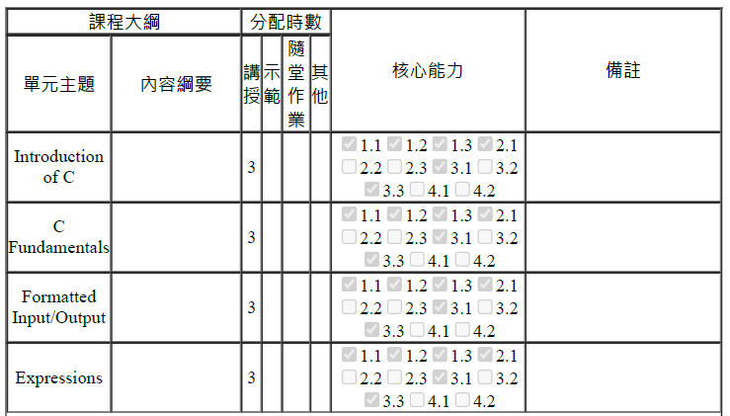
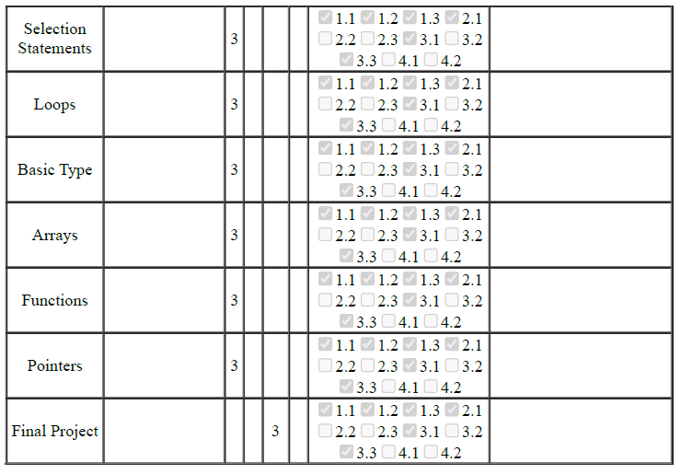
教育目標
- 專業基礎知識. 使學生擁有扎實的專業基礎知識，成為資訊及相關領域的專業人才
- 培養創造能力. 使學生具有運用所學到的各種專業知識與理論以科學的方法解決問題與創新
- 自我挑戰能力與終身學習. 讓學生習於自我挑戰、獨立思考，學會思維創新、領導及組織團隊、有效溝通、終身學習之能力
- 社會人文素養與國際視野. 讓學生具備關懷社會的情操與人文素養，並具國際觀，奉獻社會國家及人類
核心能力
1.1.具有資訊工程相關基礎知識之吸收與了解的能力(Capability to grasp foundationalknowledge in computer science.)
1.2.具有運用資訊工程理論及應用知識，分析與解決相關問題的能力(Capability to usecomputer science theory and application knowledge to analyze and solve related problems.)
1.3.在資訊工程的許多領域中，具有至少某一項專業能力，例如：硬體、軟體、多媒體、系統、網路、理論等(Professional in at least one area, including hardware, software,multimedia, system, networking, and theory.)
2.1.具有資訊工程實作技術及使用計算機輔助工具的能力(Capability to perform computerscience implementations and use computer-aided tools.)
2.2.具有設計資訊系統、元件或製程的能力(Capability to design computer systems,components, or processes.)
2.3.具有科技寫作與簡報的能力。(Capability to write and present technical materials.)
3.1.具有除了已有的應用領域之外，亦可以將自己的專業知識應用於新的領域或跨多重領域，進行研發或創新的能力。(Capability to apply one’s professional knowledge to a newapplication domain or across multiple different application domains.)
3.2.具有領導或參與一個團隊完成一項專案任務的能力並且具有溝通、協調與團隊合作的能力。(Capability to lead or participate in group projects, with effective communication,coordination, and teamwork.)
3.3.具有因應資訊科技快速變遷之能力，培養自我持續學習之能力。(Capability to adapt torapidly changing computer science technology and to develop self-learning capabilities.)
4.1.具有社會責任、人文素養及奉獻精神。(The awareness of social responsibilities,humanity, and contribution.)
4.2.具有工程倫理、宏觀能力、國際觀及前瞻視野。(The awareness of engineering ethics,broad capabilities, and global and contemporary vision.)

請尊重智慧財產權，不得非法影印教師指定之教科書籍
