管院學士班課程大綱
BA/BBA Program Syllabus
2019.12.16修訂
系所Department | 資訊管理學系 Information Management |  |  |  |  |  | 必選修compulsory/elective |  |  | 選修Elective  (醫資所必先修)
課程名稱  Course title | Management for Healthcare Organizations/醫務管理 |  |  |  |  |  | 學分數Credit(s) |  |  | 3
學年/學期academic year/Semester | 115-1學期 Fall semester 2026 |  |  |  |  |  | 上課地點Classroom |  |  | 管院616B
講授教師  Instructor | 林育秀 |  |  |  |  |  | 上課時間  Time |  |  | Monday,  13:10~16:00
教師辦公室&諮詢時間 Instructor office number & office hour |  | 管院614  Monday |  |  | 教師聯絡資訊  Instructor Contact |  |  |  | Phone: #34614  Email: yuhsiu@ccu.edu.tw
助教  Teaching assistant |  | TBA |  |  | 助教 聯絡資訊  TA contact |  |  |  | Email: TBA
先修課程  Pre-requisite courses | N/A
課程目標  Course Objective | This course provides an overview of health care that thoroughly addresses health care and public health care services. During the course, you may learn and understand: the health care services delivery system, the major players in health care services, and the challenges in health care delivery. In addition to the usual topics in an introduction to health care services, this course further provides extensive coverage of the chronic disease epidemic, discussions about the community-centered health home model, and pursuit of quality care.
AACSB學習品質保證學習目標 Assurance of Learning (AOL) Learning goals
*請先選填為主要或次要學習目標(Major or minor learning goal)，再選擇對應之學習目標
主要學習目標 Major learning goal  目標4：全球視野 LG4:Global Perspectives |  |  | 次要學習目標 Minor learning goal  目標3：問題解決能力 LG3:Problem Solving Skills |  |  |  |  | 次要學習目標 Minor learning goal  目標5：商業倫理 LG5:Business Ethics
教材  Teaching materials | - Buchbinder, S. B. & Shanks, N. H. (2020). Introduction to health care management. Jones & Bartlett. (ISBN: 9781284081015)  - Healey, B. J. (2015). Introduction to health care services: foundations and challenges. Jossey-Bass, A Willey Brand.  - Gupta, S. D. (2022). Healthcare System Management: Methods and Techniques. Springer. ISBN: 978-981-19-3075-1; eBook ISBN: 97-981-9-3076-8.  - Kiel, J. M., Kim, G. R., Ball, M. J. (2022). Healthcare information management systems: Case, strategies, and solutions. Fifth edition. Springer. ISBN: 978-3-031-07911-5; eBook ISBN: 978-3-031-07912-2.
網址Course website | E-course
教科書/參考書  Textbooks/Reference | - Lee, P. C., Wamg, T. H., Chen, C. H., Peng, C. H. (2022). Digital health care in Taiwan: innovations of national health insurance. Springer. (ISBN: 978-3-031-05160-9) (e-BOOK available)
評量方式(請填百分比)  Assessment | 課堂參與 Participation |  |  | 25% |  | 個案討論 Case study |  |  |  |  | 35%
評量方式(請填百分比)  Assessment | 作業Homework |  |  | 20% |  | 專題 Project |  |  |  |  | %
評量方式(請填百分比)  Assessment | 小考Quiz |  |  | % |  | 其他1 other ( ) |  |  |  |  | %
評量方式(請填百分比)  Assessment | 期中考Midterm |  |  | % |  | 其他2 other ( ) |  |  |  |  | %
評量方式(請填百分比)  Assessment | 期末考Final |  |  | 20% |  | 其他3 other ( ) |  |  |  |  | %
評量方式(請填百分比)  Assessment | 報告Presentation |  |  | % |  | 其他4 other ( ) |  |  |  |  | %
其他說明  Other description | - Academic Honesty: Academic integrity policy, based on the law: https://goo.gl/z6UqZ2 (Please read and understand). Most students are expected to be honest in your academic work, hence, you are expected to comply with the law. All research papers/assignments will be submitted through SafeAssignment to verify the originality of work and the adequacy of citation of sources.  - Assignments are due on dates and at times note: Under normal circumstances, late work will NOT be accepted without prior agreement, except in the case of an emergency. You should contact me directly via e-mail if you have difficulty submitting an assignment on time. All assignments are due by close of business (COB) the day.  - Student Disabilities: Please contact me personally at the beginning of the semester if you have a condition or disability that may interfere with your performance in this course. We can discuss accommodations that may be necessary to allow you to participate fully and to facilitate your learning opportunities in the class.

課程規劃表Course Schedule
週次  week | 日期  Date | 內容  Description | 教材章節  Textbook | 其他說明  Remark
1. | 9/7 | Introduction
2. | 9/14 | An overview of health care management
3. | 9/21 | Healthcare service delivery: providers and hospital
4. | 9/28 | Break
5. | 10/5 | Guest lecture  Speaker: 中國醫藥大學醫務管理學系王中儀教授  Topic:智慧醫療智慧
6. | 10/12 | Healthcare service delivery: public health services
  陳冠維 | 薛閔容 | 洪婉玲
7. | 10/19 | Quality improvement basics
  林圻珀 | 陳靖達 | 謝孟珈 | 林奇安
8. | 10/26 | Break
9. | 11/2 | Midterm--Case study group discussion
10. | 11/9 | Financing health care and health insurance
  林柏澈 | 陳靖達 | 洪婉玲
11. | 11/16 | Ethic and Law
  林圻珀 | 林柏澈 | 莊佳俊 | 謝孟珈
12. | 11/23 | AI in Healthcare  https://www.youtube.com/watch?v=0EW3uUCCoUc
  薛閔容 | 陳冠維 | 林奇安 | 莊佳俊
13. | 11/30 | - Case study 1: ESG in Healthcare  Case study 2: Blockchain in healthcare
  陳冠維
14. | 12/7 | Case study 3: Telemedicine  Case study 4: Big data in healthcare
  洪婉玲 | 謝孟珈
  林圻珀 | 薛閔容
15. | 12/14 | Case study 5: Smart healthcare  Case study 6: Digital transformation
  林柏澈 | 陳靖達
16. | 12/21 | Final
17. | 12/28 | Self-learning: Health keeper movie 1
18. | 1/4 | Self-learning: Health keeper movie 2

Conceptual framework (15%)
Each of you need to submit TWO conceptual framework during the whole semester. However, for each CHAPTER (not case study) only allows 5 students (to be determined) to present it. Therefore, you need to arrange your own work and report what you selected to TA. You need to read those assigned paper, and prepare ONE conceptual framework. You may allow apply any generative AI tools for preparing your work. However, you need to reveal the tool and prompts. For this work, you may only submit WORD or PDF documents. File name: Student number-Name-Week number, e.g: 5******-林育秀-Week 6.

How to develop a conceptual framework?
For each class, students will identify (working individually, no group work) among the readings representing major issues on the topic. You will use the major issues or factors to develop a conceptual framework that represents the core issues with the causal/ mediating variables impacting the core issues/phenomena/ players (as applicable) within the topic of the day. (I will present one as an example the first day of class.)

A CONCEPTUAL FRAMEWORK IS A MENTAL MAP OF THE TOPIC. IT CAPTURES THE KEY ELEMENTS, IDENTIFIES WHAT ARE THE CAUSAL AND EFFECT VARIABLES, THE RELATIONSHIPS AND DIRECTION OF RELATIONSHIPS, IN THE TOPIC.

You will turn in this conceptual framework before the class each day. You should be prepared to defend your conceptual framework. Additionally, all students will come fully prepared to actively discuss, raise issues, and answer questions in the course of the students’ presentation. If time permits, any random student can be asked to present their own framework to class just highlighting what is different about their own framework compared to the presenters.

After class, I will put up on e-Course a pdf document of all your frameworks to all class students so that you all have a chance to improve your conceptual frameworks for future.

For students who miss class for whatever reason, you will prepare a full NARRATIVE paper to explain your own framework, along with coverage of all articles and turn it in along with your framework on the next class day. This will give me a sense of your thought process that led to your framework that you could not be present in class to share. There is no page length limits for this paper. Use what you need to describe your framework and pull in material from all papers with citations.

Assigned reading:
- Quality improvement basics
  - Improving patient outcomes through effective hospital administration: a comprehensive review
  - Service quality in the healthcare sector: a systematic review and meta-analysis
  - Quality of healthcare services in focus: the role of knowledge transfer, hierarchical organizational structure and trust
- Financing health care and health insurance
  - The Lancet Global Health Commission on financing primary health care: putting people at the centre
- Ethic and Law
  - Legal and ethical consideration in artificial intelligence in healthcare: who takes responsibility?
  - The ethical issues of the application of artificial intelligence in healthcare: a systematic scoping review
  - Ethical, legal, and social considerations of AI-based medical decision-support tools: a scoping review
- AI in Healthcare
  - Shaping the future of AI in healthcare through ethics and governance
  - Large language models for improving cancer diagnosis and management in primary health care settings
  - Challenges to implementing artificial intelligence in healthcare: a qualitative interview study with healthcare leaders in Sweden

Case study (40%--15% for oral presentation, 25% for paper)
The term paper will be arranged 6 case studies. Students are required to complete one FIVE-page research paper on the topic of their choice and to submit their research paper in the week BEFORE the presentation week and due by close of business (COB) the day.

Paper will use the following format (Language use: Mandarin or English)

Main Text. The text of the article is limited to FIVE TO SIX pages in English or SEVEN TO EIGHT pages in Mandarin with SINGLE spaced pages, NOT including the cover page and reference pages (or abstract and table of contents which are not required - but if used). Charts, graphs, photos, drawings, lists and extended quotes will NOT count against the assigned pages of written text required.

- Introduction: Based on the reference paper, you need to develop a conceptual framework (one page), and a brief introduction of your conceptual framework (No longer than 1.5 pages).
- What this issue talking about?
- Why this issue important?
- What should we learn from this issue?
- Conclusion.
- References. The APA 7 standard will be used. A minimum of 5 references must be used. Your references should consist primarily of peer-reviewed journal articles. References can include material from the Internet if from a reputable source. Wikipedia is NOT a reputable source. Reputable sources include government agencies and professional organizations, for data and policy statements. Citations should be presented in APA 7 format. The Word “footnote” function can be used to accomplish this if you do not have EndNote.

Tables/graphs should immediately follow the references.

Teamwork sheet. Please to identify your responsibilities in your term paper. Each one should be assigned at least one work, but not summarized or oral presentation.

Declaration of generative AI in academic writing. You must disclose the use of generative AI and AI-assisted technologies in the writing process by adding a statement. Also, you need to provide the transcripts as the attachment.

Oral presentation
You will present your papers and share ideas in class. Presentations are to be in PowerPoint (not PDF or Canva), with effective use of margins, white space, and templates that are professional and easy to read. Insert page numbers on all assignments. Each group will have sufficient time to present their own work, and the length will be 40-60 minutes. Every student should present at least 5 minutes. Other groups SHOULD point out at least one question for the topic. You may grade others work inter- and intra-group. Please do your best.

Topic:
- ESG in Healthcare
  - Impact of green human resource management towards sustainable performance in the healthcare sector: role of green innovation and risk management
  - How to manage sustainability in healthcare organizations? A processing map to include the ESG strategy
  - The Role of Strategic Management in the Big Data and ESG Integration in the Global Healthcare Management Market
- Blockchain in healthcare
  - Can Blockchain Improve Healthcare Management
  - A systematic study on integrating blockchain in healthcare for electronic health record management and tracking medical supplies
  - Evaluating the impact of blockchain technology in healthcare data management: A review of security, privacy, and patient outcomes
- Telemedicine
  - Revolutionizing healthcare: how telemedicine is improving patient outcomes and expanding access to care
  - A review of emerging trends in telemedicine: Healthcare delivery transformations
  - Health management via telemedicine: Learning from the COVID-19 experience
  - Evolution of smart healthcare: Telemedicine during COVID-19 pandemic
- Big data in healthcare
  - The management of digital competence sharing in health care: A qualitative study of managers' and professionals' views
  - A comprehensive review of data analytics in healthcare management leveraging big data for decision-making
  - Big data analytics in the field of multifaceted analyses: a study on “health care management”
  - Data analytics in healthcare: a review of patient-centric approaches and healthcare delivery
- Smart healthcare
  - Where do models for change management, improvement and implementation meet? A systematic review of the applications of change management models in healthcare
  - Evaluation of challenges for adoption of smart healthcare strategies
  - AI-assisted facial analysis in healthcare: From disease detection to comprehensive management
- Digital transformation
  - Digital transformation in healthcare: Analyzing the current state-of-research
  - From electronic health records to clinical management systems: how the digital transformation can support healthcare services
  - Digital transformation in healthcare: insights on value creation
  - Digital transformation, for better or worse: a critical multi‐level research agenda

Examinations
Quiz and final examination will be held on Monday. Students should NOT discuss the exams or work in groups.

Self-learning

CCU library: Theme of SDGs, Film Festival
Topic: Health Keeper
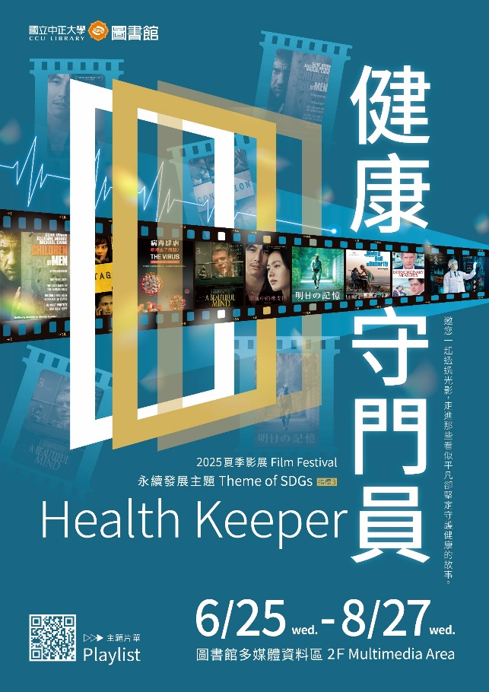
Link: https://ccu.primo.exlibrisgroup.com/discovery/collectionDiscovery?vid=886CCU_INST:886CCU_INST&collectionId=81176908030007979&lang=zh-tw
Please select TWO films from the list of 42 titles that genuinely interest you. After watching them, write an essay (500–1000 words) in which you reflect on and critically engage with the content, themes, or messages presented in the films.

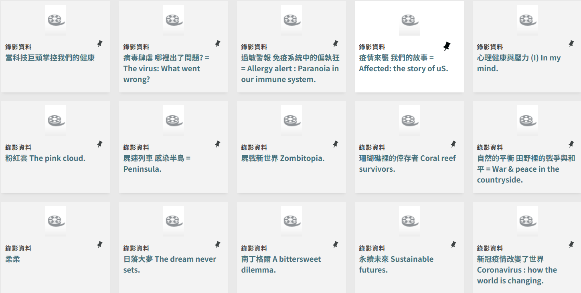
1 2 3 4 5

6 7 8 9 10

11 12 13 14 15

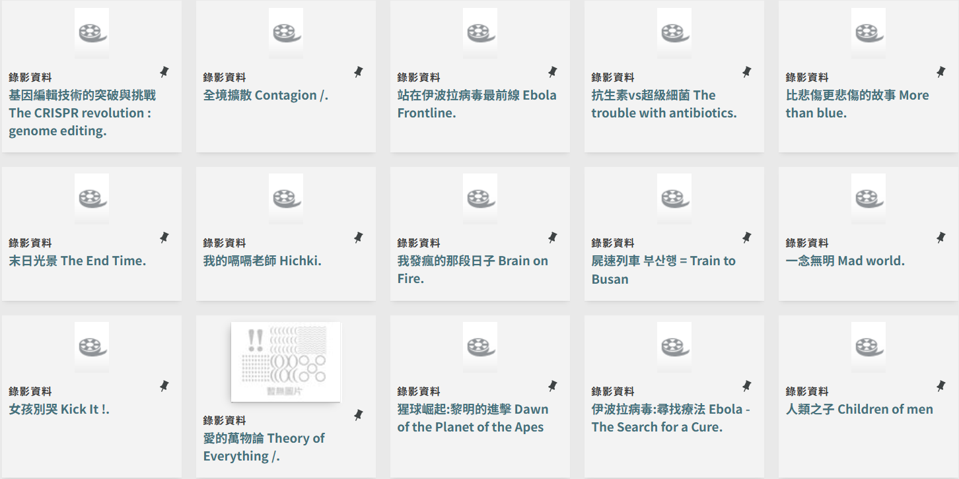
16 17 18 19 20

21 22 23 24 25

26 27 28 29 30

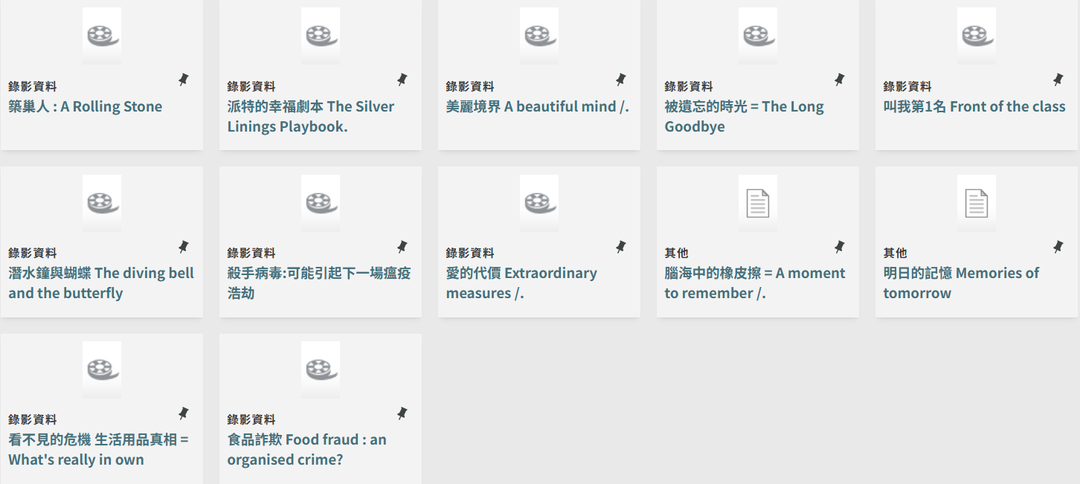
31 32 33 34 35

36 37 38 39 40

41 42

Use of Cell phones and Laptop Computers in Class
Cell phones are to be turned off and put away during class unless otherwise instructed. You may use of laptops, I-pads, I-phones, or other electronic devices during class, but please only apply in our course not others. All students are required to be fully engaged throughout and highly encouraged to make (hand-written) notes actively.

The rubric for grading papers and conceptual frameworks as following. Similar considerations will be used for grading class participation.
CATEGORY | 10 | 7 | 4 | 1 | Total points
Paper text (20%) | Covers major points and needs no further explanation | Can be understood but some major points not covered | Contains digressive descriptions with nil or marginal relevance | Too general to be a scholarly paper/proposal
Integration of knowledge & depth of discussion (20%) | The paper demonstrates that you fully understand and has applied concepts learned in the course. In-depth discussion and elaboration in all sections of the paper. | The paper demonstrates that you, for most part, understands and has applied concepts learned in the course. In-depth discussion and elaboration in most sections of the paper. | The paper demonstrates that you, to a certain extent, understands and has applied concepts learned in the course. The writer has omitted pertinent content or content runs-on excessively. | The paper does not demonstrate that you fully understood and applied concepts learned in the course. Only brief discussion in a few sections of the paper.
Neutral Voice (20%) | Uses neutral voice (no bias) | Contains slightly perceived bias (deviation in a direction away from the articles' themes) | Contains perceived bias (persistent focus on a contradiction or direction that is inconsistent with assigned articles) | Obviously one-sided bias or mostly focused on personal opinions/anecdotes
Synthesis of Complex Information (15%) | Synthesized information from many sources, logical progression throughout | Contains logical progression of thought | Difficult to follow presented information | Contains digressive illogical sequence of thought
Topic/Issue Conclusions (15%) | Conclusive statements are logical based on material presented and supported by assigned papers | Conclusions are not readily apparent but can be inferred based on facts indicated in the paper | Conclusions are questionable and unsupported by evidence/expert sources | Conclusions are illogical
CONCEPTUAL FRAMEWORK SCORING | Comprehensively covered key elements/concepts from assigned papers, direction of associations accurate, precise and concise constructs | Captured most of the key elements available, directions of association accurate | Lack of precision in concepts captured, Patchy capture of constructs, several articles not represented in CF | Difficult to identify a meaningful train of thought, causal or relational pathways

