國立中正大學通識教育課程教學大綱
開課學年度/學期 | 114學年度第2學期
課程名稱(中文) | 永續發展
課程名稱(英文) | Sustainable Development
課 碼 | 7500016 | 學分數 | 2
向度別
  □中英文能力課程 | □基礎概論 | □資訊能力
  □藝術與美學 | █能源、環境與生態 | □人文思維與生命探索
  □公民與社會參與 | □經濟與國際脈動 | □自然科學與技術
授 課 方 式 | 請勾選(可複選)：
  ■課堂授課 | ■網路教學 | ■分組討論 | █校外教學
  □其他
教學目標及範圍 | The aim of this course is mainly divided into two categories.  The first category is about how to deal with the environmental issues, focusing on (1) maintaining the sustainability with one’s humbleness and prudence, (2) emphasizing the “natural goodness” in those environmentally sensitive areas with the awareness that the entrapment of human beings will eventually lead to natural disasters, and it is better to return the land to nature and let time heal the damaged land naturally, and (3) promoting toward the green buildings in order to pursue the rapid and high economic growth in the development on the premises of environmental sustainability. In terms of fulfilling the aim to achieve the cooperation between economic growth and environmental sustainability, changing the way the industries act in the current pattern is especially important.  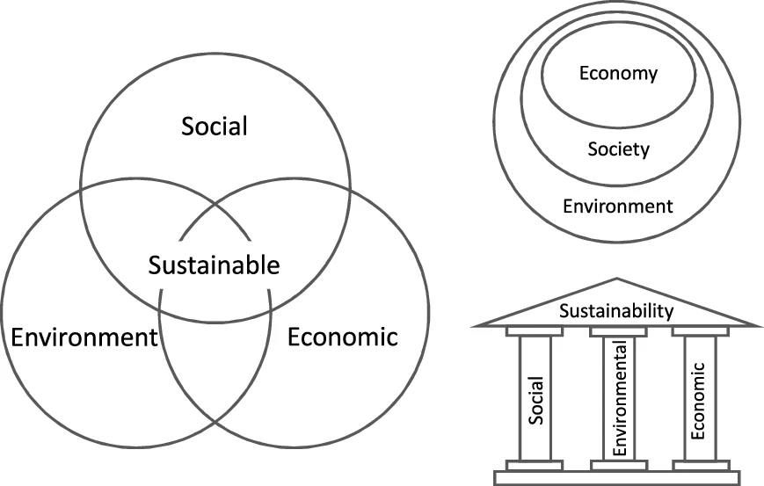  In the second category, students will learn about how to participate in the “green industry” through action-oriented learning. Students need to understand that “there should be the balance between environmental development and sustainability.” They should engage themselves in the non-toxic cleaning way and eco-consumerism toward nature to advocate for the ideal of the social equality, population health, and society development( Figure1). In view of this, Center for General Education at CCU offers this course in the field of Natural Sciences, which emphasizes the importance of both problem-solving and action-oriented aspects in the environmental sustainability.  Figure 1  【Creativity in the class】  1. Problem solving  a. Students come from different fields and disciplines, and the instructor will talk about the outline in the first class with extended materials (Figure 2).  b. Then, the course lecture will emphasize on self-learning (Figure 3).  c. Also, students will learn how to cooperate as they work together on tasks. Basically, the students will be divided into a few groups with 3-5 students for each group.  d. Self-constructed curriculum: As students solve a series of problems, they also need to build the curriculum for their own learning team.  e. Feedbacks on coursework: Students will discuss and have consensus on different issues at the end of weekly course. Later, they should make records of these feedbacks and upload to the internet.  Figure2  Figure3  2. Action-oriented learning  Advocating the idea about the action-oriented learning in the university is also one of the important achievements in liberal education. Action-oriented learning emphasizes the importance of the caring and participation from students to the solar energy-saving products and implementing successful green marketing programs. There will be a field survey afterwards. By carrying out the goals from the Taiwan Sustainable Campus Project held by the Ministry of Education mentioned above, students can pick up the spirit from the action learning and the concept of “learning by doing.”  【The goals】  1. With problem solving skills, students will ponder upon the value of sustainability. Therefore, they can understand that sustainable development is one of the most important issues when it comes to nature in the 21st century. In the past, human beings did damage to ecology for enormous profits. Now, sustainable development such as green purchasing, eco-friendly actions, and environmental marketing is the priority when it comes to the development of human beings.  2. Through action-oriented learning, students will be able to understand the mechanisms behind sustainable development, the theory behind the green industry, and the principles of ecological energy conservation. Since the private organizations and the government are reusing the resources which are related to solar thermal energy and biofuel, they can provide safe, efficient, environmentally friendly, and low-cost services to the public.  3. Through action-oriented learning, students will be able to understand how the solar energy-saving systems work, and they are able to reflect that there is only one earth, knowing that it is necessary for human beings to cherish resources, protect the environment, and enjoy a green life.  4. The experts and scholars outside the university will talk about the cases related to environmental sustainability, and therefore, students are able to reflect upon the issues which are about what the earth’s resources are and how the sustainable environment is treated by human beings in this society. With the idea of anti-anthropocentrism, human beings should advocate for the green production, green consumption, source reduction, resource recovery, reuse, and recycling to achieve the vision of “full recycling and zero waste.”  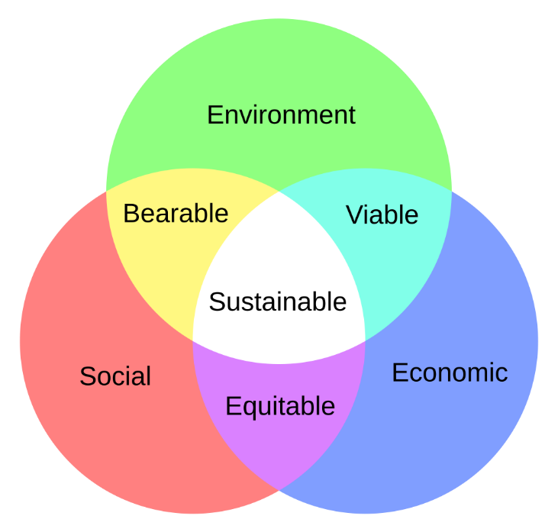
與通識教育核心精神之關聯性 | Students will be guided to know the importance of environmental sustainability, and they will also be aware of the environmental ethics in the general education curriculum Figure 4. Students will be able to play full and active advocators in “going green.”  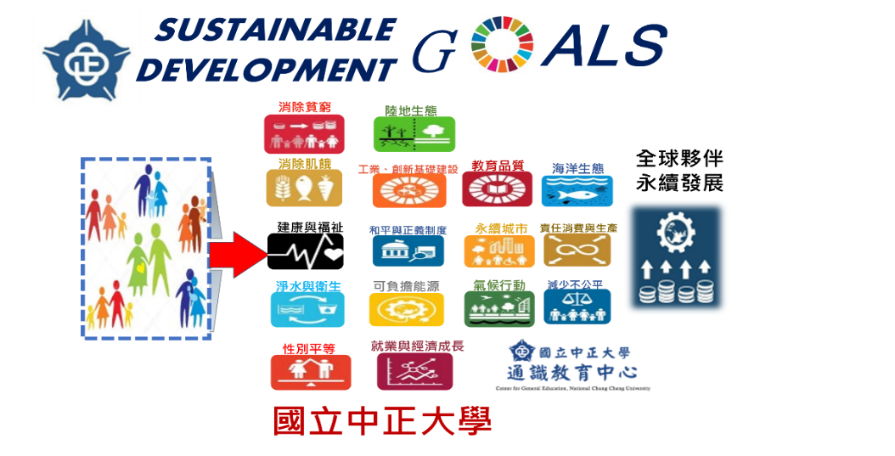  Figure 4  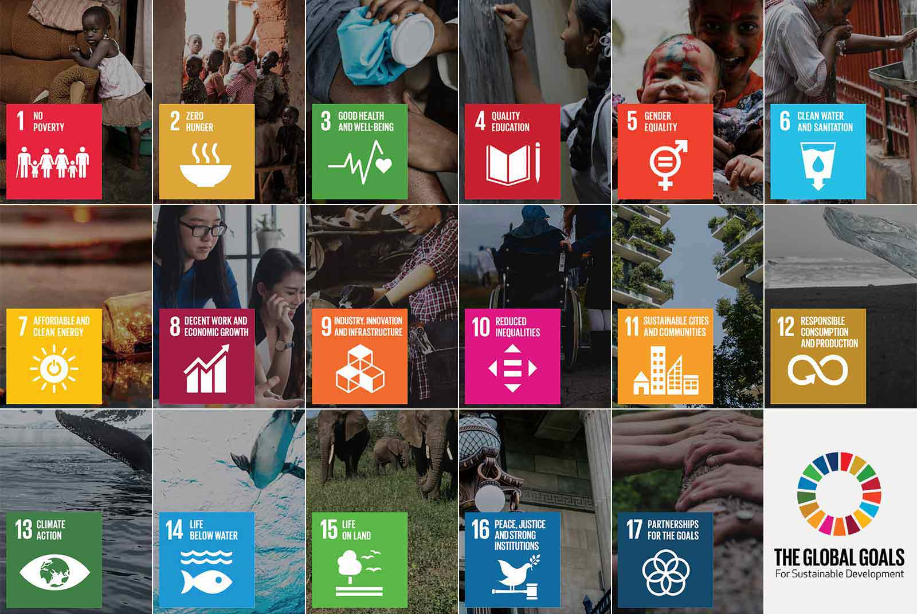  Figure 5
授 課 大 綱  (須含週次表及每週課程進度說明) | The schedule:  Week 1 Advocating the importance of sustainable development  a. The three principles  b. The explanation to how the evaluation of the grades goes and the direction the class is going to follow  c. group discussions  Week 2 Sustainable development – human and nature  a. The hypothesis  b. The schedule  c. group discussions – 2-4 students in each group & 20 mins for discussion  d. reflection  Week 3 Sustainable development－environmental ethics  a. The hypothesis  b. The schedule  c. group discussions – 2-4 students in each group & 20 mins for discussion  d. reflection  Week 4 The trilogy to the sustainable development  a. The hypothesis  b. The schedule  c. group discussions – 2-4 students in each group & 20 mins for discussion  d. reflection  Week 5 The technics to the recycling  a. The hypothesis  b. The schedule  c. group discussions – 2-4 students in each group & 20 mins for discussion  d. reflection  Week 6 The technics to the green building  a. The hypothesis  b. The schedule  c. group discussions – 2-4 students in each group & 20 mins for discussion  d. reflection  Week 7 The indicators to the green building  a. The hypothesis  b. The schedule  c. group discussions – 2-4 students in each group & 20 mins for discussion  d. reflection  Week 8 The technics to the biodiversity  a. Topsoil preservation, ecological status of surface waters, ecological status of slopes, and soil porosity  b. The application of the digital ppt  c. group discussions – 3-5 students in each group & 20 mins for discussion  Week 9 The midterm exam  Week 10 The action-oriented learning – the sustainable campus  a. Touring CCU  b. Pondering upon the efficiency of the sustainable development in CCU  Week 11 The industry to the environmental sustainability  a. The basic introduction of the Zhongsha Bridge  b. The construction of the Zhongsha Bridge  c. Sharing between students’ thoughts and comments  d. reflection  Week 12 The management to the constructed wetland in the campus  a. The constructed wetland  b. Water quality monitoring  c. group discussions – 3-5 students in each group & 20 mins for discussion  d. reflection  Week 13 The intelligent buildings  a. indicators and the basic concepts  b. group discussions – 3-5 students in each group & 20 mins for discussion  c. reflection  Week 14 Ecotourism  a. The benefits & experiences  b. The hypothesis  c. group discussions – 3-5 students in each group & 20 mins for discussion  d. reflection  Week 15 Eco-cities  a. The initiation to the Eco-cities & the basic concepts  b. group discussions – 3-5 students in each group & 20 mins for discussion  c. reflection  Week 16 Healthy cities  a. The basic introduction – environment, society, and human  b. group discussions – 3-5 students in each group & 20 mins for discussion  c. reflection  Week 17 Green consumerism  a. The reduction of the industrial waste  b. Cleaner production  c. group discussions – 3-5 students in each group & 20 mins for discussion  d. reflection  Week 18 The final exam
  Week | theme
  1 | The introduction to the course and the final confirmation about the number of the students
  2 | Sustainable development – human and nature
  3 | Sustainable development－environmental ethics
  4 | The trilogy to the sustainable development
  5 | The technics to the recycling
  6 | The technics to the green building
  7 | The indicators to the green building
  8 | The technics to the biodiversity
  9 | The mid-term exam
  10 | The action-oriented learning – the sustainable campus
  11 | The industry to the environmental sustainability
  12 | The management to the constructed wetland in the campus
  13 | The intelligent buildings
  14 | Ecotourism
  15 | Eco-cities
  16 | Healthy cities
  17 | Green consumerism
  18 | The final exam
教科書及參考書 | 【教科書】  1. Self-editing  2. 永續發展策略(詹氏書局)  【參考書目】  1. 江哲銘(2004)，永續建築導論，建築情報，台北。  2. 關秉寅(2007)，問題導向與行動導向的通識教育，國立政治大學社會系專題。  3. 洪榮昭(2005)，問題導向學習課程發展理論與實務，師大書苑。台北  4. 林平勻(2003)，問題導向學習在成人科技教育的應用，生活科技教育月刊，36卷，第八期。台北  5. 王從恕(2004)，從西方環境倫理探討資源管理的正當性，環境資源經濟、管理暨政策學術研討會論文，中央研究院經濟研究所。台北  6. 黃俊傑(2005)，大學通識教育的理念與實踐。台北:樂學。  7. 楊冠政(1996)，人類環境倫理信念的演進，環境教育季刊28:7~20。  8. 白子易、莊順興(2006)，環境科學概論，高立圖書有限公司  9. 於幼華(2002)，環境與人，遠流出版社。  - 賴明洲(2006)，永續建築及景觀的實物生態學，明文書局。WF(1991),Living Planet Report1991,WWF  - Evensen, D. H.＆ C. E.Hmelo, eds.(2000). Problem-based Learning:A Research Perspective Learning Interactions. Mahwah, NJ: Lawrence Erlbaum Associates.  - Bernyi, E. B.; Gould, R. N.1993-1994 Resource Recovery Yearbook; Governmental Advisory Associates Inc., New York, 1994.  - DesJardins J.R.(1993)，Environmental ethics: an introduction to environmental philosophy.，Wadsworth, Inc. Belmont, California.  - Mumford, A.(1995)，Learning in Action. Industrial and Commercial Training,27(8), 36~40.  - Stanmore,B.R.(2002)，Modeling the formation of PCDD/F in solid waste incinerators; Chemosphere 47,565-573.  Taiwan－Japan Sciences ＆Technology Forum，(2007/09/13~14)
評 量 方 式 | 請勾選(可複選)，並填寫類別：  A類佔30 %；B類佔30 %；C類佔 20 %；D類佔20 %(類別可自行增加)  說明：
  ■課堂參與， A 類 | ■期 中 考， C 類 | ■期 末 考， D 類 | □小組報告， 類
  ■小組討論， B 類 | ■書面報告， B類 | □課後作業， 類 | □平時測驗， B 類
  ■心得分享， A類 | ■學習紀錄， B類 | □專題創作， 類 | □其他 ， 類
與聯合國永續發展  目標(SDGs)及  細項之對應  (請參閱SDGs  對照表) | 目標: 6 細項：_6.1 6.7______  目標: 13 細項：13.1 13.2  目標: 15 細項：_15.3 15.4  (至多三個目標，每個目標至多三個細項)  範例：  目標: 4 細項：4.3 4.5 4.7
核心能力指標設定 | 說明：課程符合指標內涵之部份內容，即可勾選。請依據課程內涵判定其符合程度，勾選項數以主要的3~5項為度。
  通識課程  核心能力指標 | 說明 | 本課程能培養學生此項核心能力者請打✔ (請複選3~5項)
  (1)思考與創新 | 經由課程的訓練與引導設計，使學生能夠進行獨立性、批判性、系統性或整合性等面向的思考，或能以創意的角度來思考新事物。 | ✔
  (2)道德思辨與實踐 | 能夠對於社會、文化中相關的倫理或道德議題，進行明辨、慎思與反省，或能實踐在日常生活中。 | ✔
  (3)生命探索與生涯規劃 | 能夠主動探索自我的價值或生命的真諦，或能具體實踐在自我生涯的規劃或發展。
  (4)公民素養與社會參與 | 能夠尊重民主與法治的精神、關心公共事務及議題，或能參與社會事務及議題的討論與決策。 | ✔
  (5)人文關懷與環境保育 | 能夠具備同理、關懷、尊重、惜福等人文素養，或能擴及到更為廣泛的環境及生態議題。 | ✔
  (6)溝通表達與團隊合作 | 能夠善用各種不同的表達方式進行有效的人際溝通，或能理解組織運作，與他人完成共同的事物或目標。 | ✔
  (7)國際視野與多元文化 | 能夠了解國際的情勢與脈動，具備廣博的世界觀，或能尊重或包容不同文化間的差異。
  (8)美感與藝術欣賞 | 能夠領略各種知識、事物或領域中的美感內涵，或能據此促成具美感內涵之實踐力。
  (9)問題分析與解決 | 能夠透過各種不同的方式發現問題，解析問題，或能進一步透過思考以有效解決問題。 | ✔
授 課 教 師 | 學系： 通識中心 姓名： 李振卿 □專任 □兼任
授 課 教 師 | □教授 □副教授 ■助理教授 □講師
授 課 教 師 | 簡單學、經歷及研究領域：  學歷:博士  經歷:  台電核三施工處土木工程師  健行科技大學土木系助理教授  皇壹營造有限公司負責人.技師  國立屏東大學助理教授  台灣中小型營造業理事長、台灣區營造公會高雄市代表  行政院工程會查核委員、內政部查核委員  研究領域  氣候變遷調適減緩、永續發展、碳中和自然解方、綠色產業淨零碳管理、永續防災技術、統計方法、休閒設施防災規劃、ANP(AHP)決策方法、土木建築施工營造、環境倫理
備 註

