Using Word to format tables

Original table
Type | Voltage  (kV) | Capacity  (MVA) | Cross-sectional area  (mm²) | Rated  Current  (kA) | Unit length resistance  (Ω) | Unit length reactance  (mH) | Unit length  capacitance  (uF)
Land cable 1 | 161 | 220 | 500 | 0.789 | 0.0508 | 0.442 | 0.15
Land cable 2 | 33 | 32.751 | 630 | 0.573 | 0.01357 | 0.1147 | 0.981
Submarine cable 1 | 33 | 42.868 | 630 | 0.75 | 0.0427 | 0.297 | 0.377
Submarine cable 2 | 33 | 21.263 | 150 | 0.372 | 0.1594 | 0.363 | 0.222

[Steps below can be done in any order]

Step 1: Align units
Select header boxes
Click Table Tools/Layout/Alignment/Bottom Center
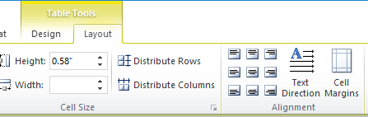

This places all the units in a row – experienced readers will know the basic content of the columns without even reading the header titles
Type | Voltage  (kV) | Capacity  (MVA) | Cross-sectional area  (mm²) | Rated  Current  (kA) | Unit length resistance  (Ω) | Unit length reactance  (mH) | Unit length capacitance  (uF)
Land cable 1 | 161 | 220 | 500 | 0.789 | 0.0508 | 0.442 | 0.15
Land cable 2 | 33 | 32.751 | 630 | 0.573 | 0.01357 | 0.1147 | 0.981
Submarine cable 1 | 33 | 42.868 | 630 | 0.75 | 0.0427 | 0.297 | 0.377
Submarine cable 2 | 33 | 21.263 | 150 | 0.372 | 0.1594 | 0.363 | 0.222

Step 2: Align decimals
(This is the least well-documented step)
Open the ruler if it is not open: View/Show/Ruler or click box at top of left slider
Click on the tab marker to choose alignment on decimal
Highlight the cells you want to align
Click on the ruler where you want the decimal to be
Decimal position can be adjusted by sliding the marker
3 click ruler
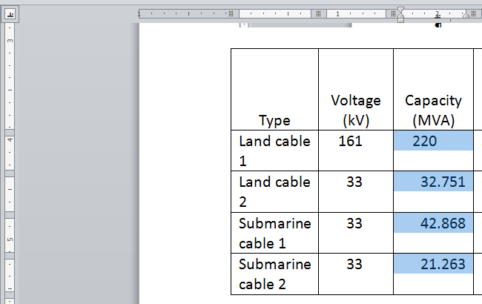
2 highlight cells
1 choose decimal

Now you will notice that within a column values are shown to different precision
Round to achieve same precision
Type | Voltage  (kV) | Capacity  (MVA) | Cross-sectional area  (mm²) | Rated  Current  (kA) | Unit length resistance  (Ω) | Unit length reactance  (mH) | Unit length capacitance  (uF)
Land cable 1 | 161 | 220 | 500 | 0.789 | 0.0508 | 0.442 | 0.15
Land cable 2 | 33 | 32.751 | 630 | 0.573 | 0.01357 | 0.1147 | 0.981
Submarine cable 1 | 33 | 42.868 | 630 | 0.75 | 0.0427 | 0.297 | 0.377
Submarine cable 2 | 33 | 21.263 | 150 | 0.372 | 0.1594 | 0.363 | 0.222

Step 3: Add spanner
Since 3 columns all talk about Unit length, combine that header
Select those three cells
Choose Table tools/layout/split cells/3 columns-2 rows
Move Unit length to the top, specific measures to the bottom boxes
Select top three cells
Choose Table tools/layout/merge cells
Capitalize new headers
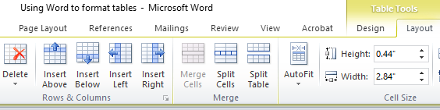
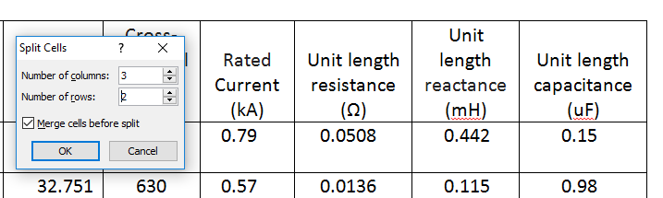

Now it is clear that the last three columns are connected
Type | Voltage  (kV) | Capacity  (MVA) | Cross-sectional area  (mm²) | Rated  Current  (kA) | Unit length
 |  |  |  |  | Resistance  (Ω) | Reactance  (mH) | Capacitance  (uF)
Land cable 1 | 161 | 220 | 500 | 0.79 | 0.0508 | 0.442 | 0.15
Land cable 2 | 33 | 32.751 | 630 | 0.57 | 0.0136 | 0.115 | 0.98
Submarine cable 1 | 33 | 42.868 | 630 | 0.75 | 0.0427 | 0.297 | 0.38
Submarine cable 2 | 33 | 21.263 | 150 | 0.37 | 0.1594 | 0.363 | 0.22

Step 4: Add stub
Select land cable 1
Choose Table tools/Layout/Insert row above
Repeat for submarine cable 1
Move “cable” to header, Land and Submarine to empty rows
Right align numbers 1 and 2 to make them subheadings
Adjust column widths

Now the connection between the cable types is clearer
Cable type | Voltage  (kV) | Capacity  (MVA) | Cross-sectional area  (mm²) | Rated  Current  (kA) | Unit length
 |  |  |  |  | resistance  (Ω) | reactance  (mH) | capacitance  (uF)
Land
1 | 161 | 220 | 500 | 0.79 | 0.0508 | 0.442 | 0.15
2 | 33 | 32.751 | 630 | 0.57 | 0.0136 | 0.115 | 0.98
Submarine
1 | 33 | 42.868 | 630 | 0.75 | 0.0427 | 0.297 | 0.38
2 | 33 | 21.263 | 150 | 0.37 | 0.1594 | 0.363 | 0.22

Step 5: Remove borders, leaving only required horizontal lines
(If you do this earlier, you use Table tools/layout/view gridlines to see the cells if necessary)
Select whole table
Choose Table tools/Design/Borders/No borders
Add horizontal lines: Method 1
Select top row of cells
Select line style and weight
Click “top border”
Repeat for other necessary lines
Add horizontal lines: Method 2
Select line style and weight
Click “draw table”
Drag cursor along row dividers to draw each
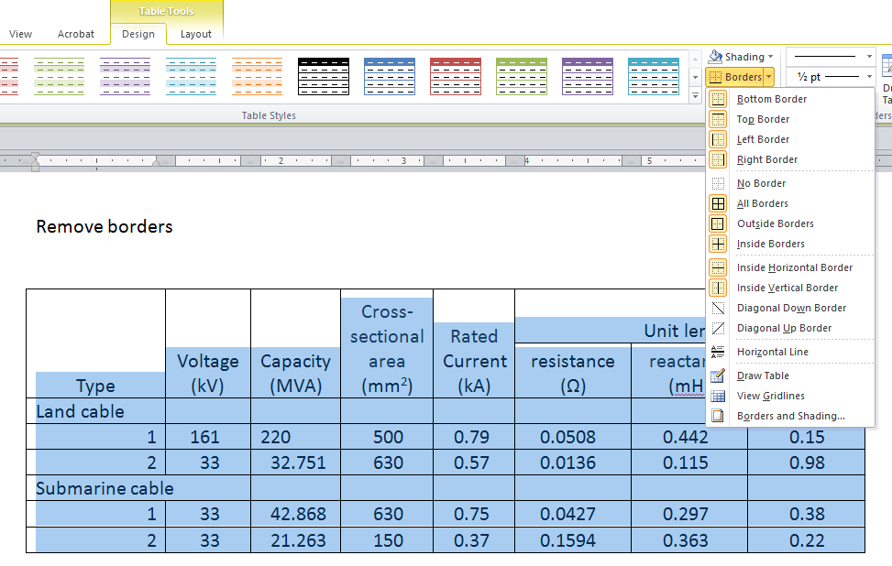

Final Table
Cable type | Voltage  (kV) | Capacity  (MVA) | Cross-sectional area  (mm²) | Rated  Current  (kA) | Unit length
 |  |  |  |  | resistance  (Ω) | reactance  (mH) | capacitance  (uF)
Land
1 | 161 | 220 | 500 | 0.79 | 0.0508 | 0.442 | 0.15
2 | 33 | 32.751 | 630 | 0.57 | 0.0136 | 0.115 | 0.98
Submarine
1 | 33 | 42.868 | 630 | 0.75 | 0.0427 | 0.297 | 0.38
2 | 33 | 21.263 | 150 | 0.37 | 0.1594 | 0.363 | 0.22

