Chapter 4-6 Sample Component Analysis
Components can be marked directly on the pdf file of a document, as illustrated below for an IMRD article. Comments on each highlight identify the component, as shown for the first in the inset. Note that in many cases, but not all, the component can be identified in the topic sentence of each paragraph. Components are summarized in the following table.

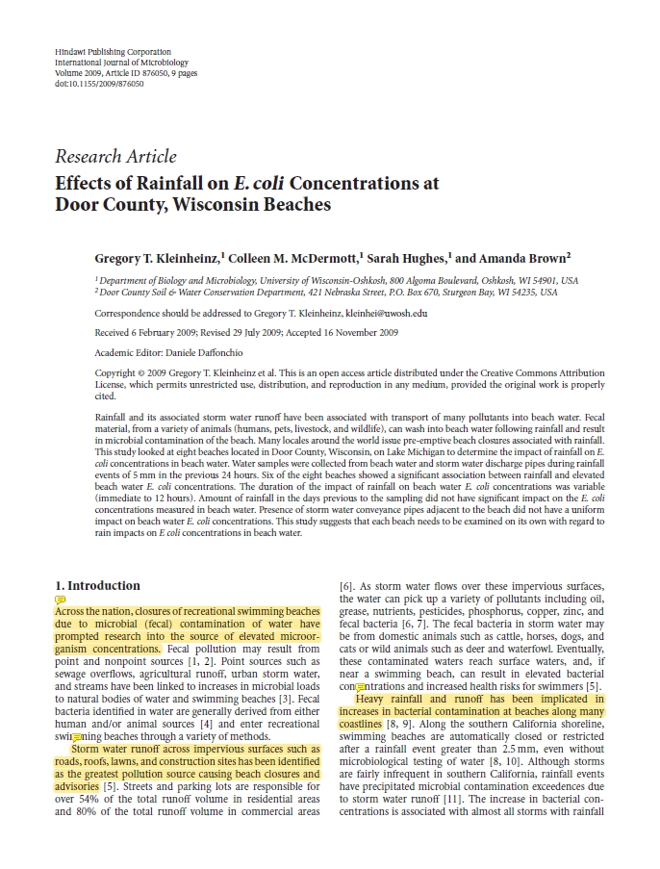
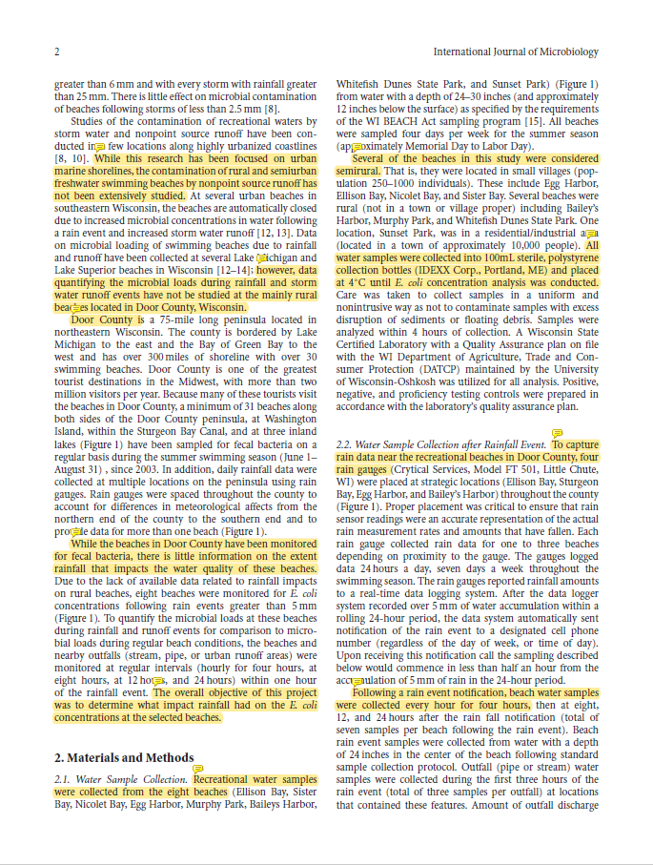

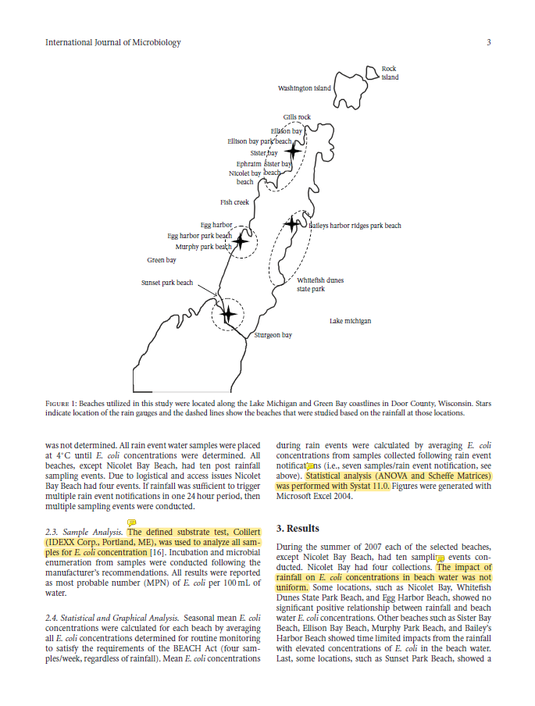

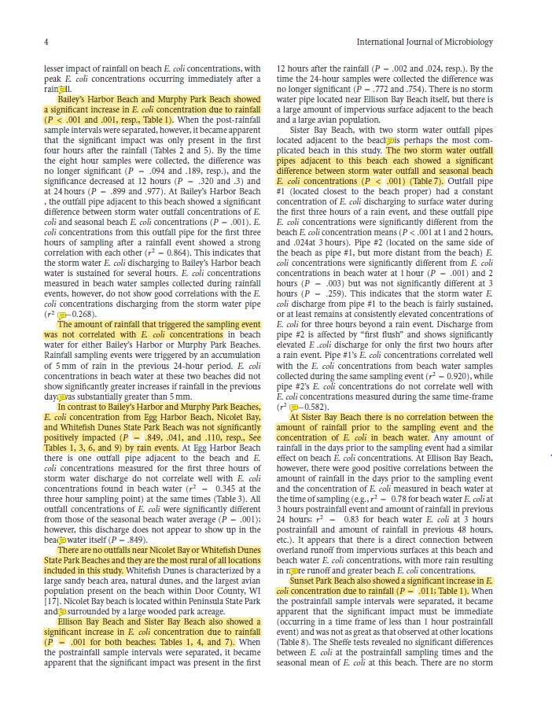

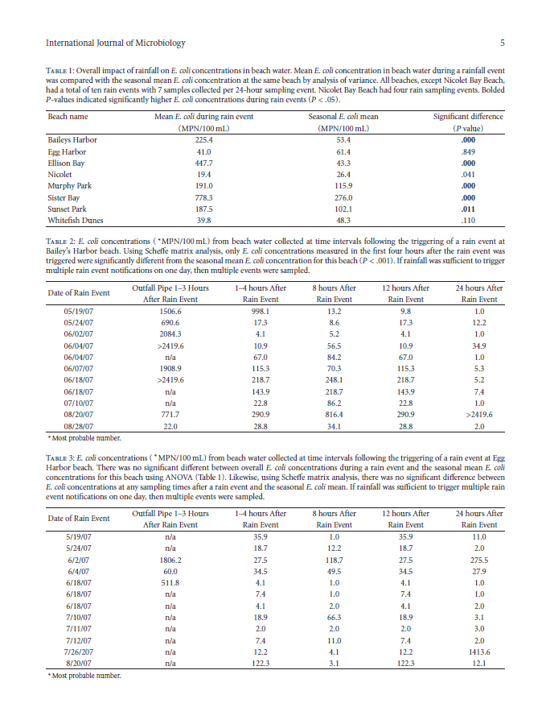

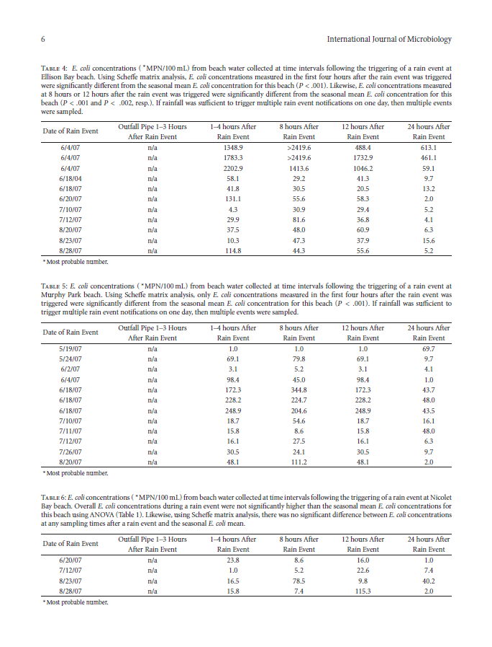

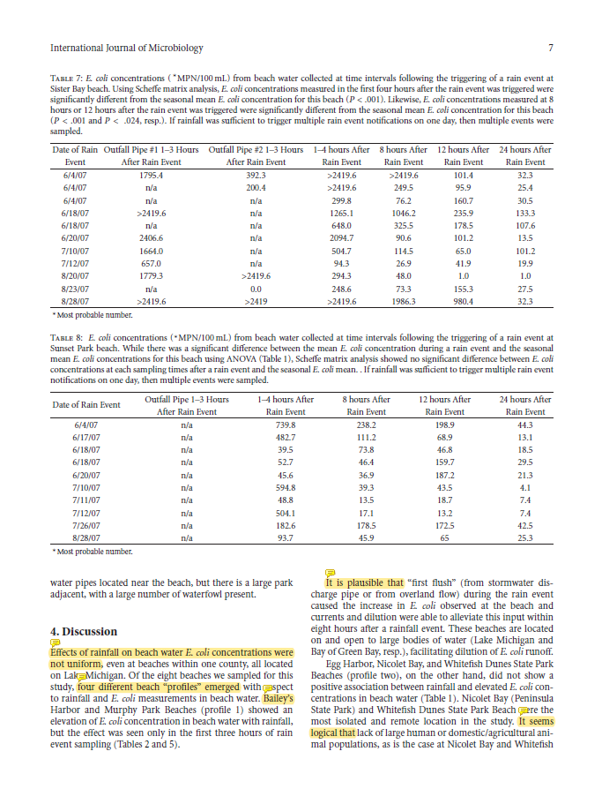

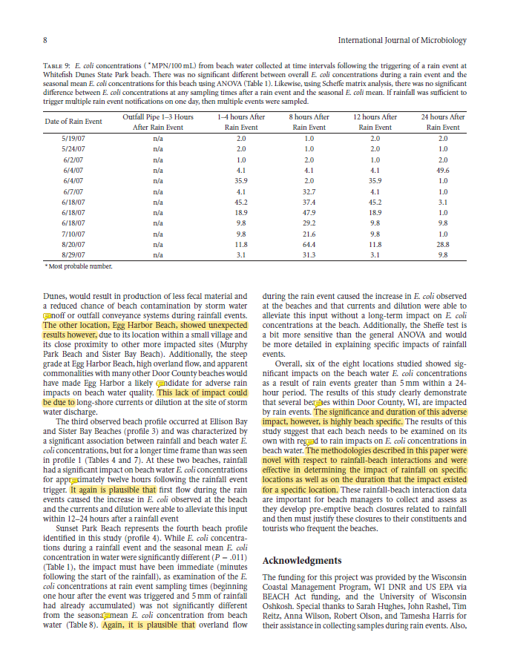

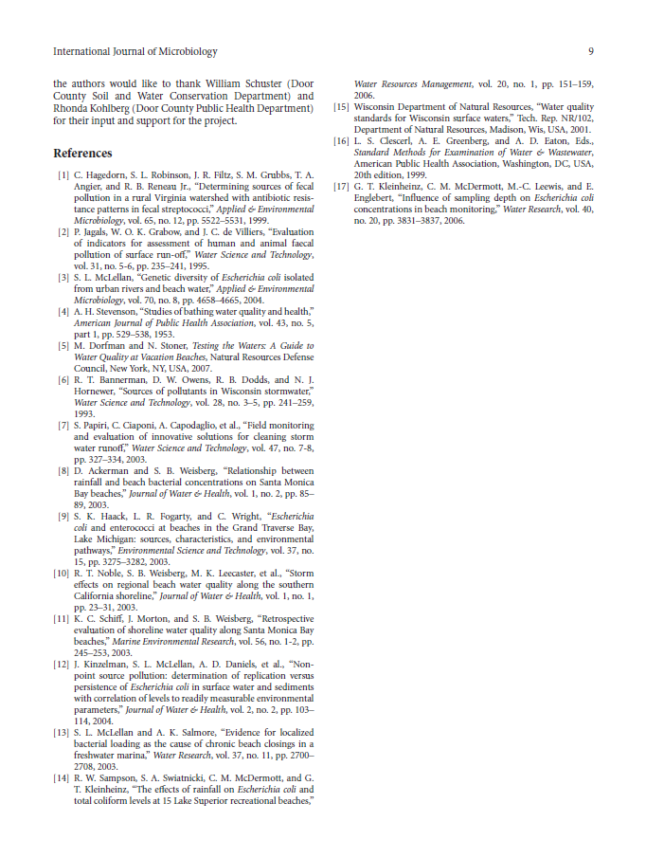
Components in Effect of Rainfall (Kleinheinz et al., 2010)
Note that the component analysis shows how the structure of the article could have been improved. As stated in the text, the sample articles were chosen by historical contingency, not for being ideal exemplars.

Section 1: Introduction
Paragraph | Key sentences, with component marker | Component (Purpose)
1 | Across the nation, closures of recreational swimming beaches due to microbial (fecal) contamination of water have prompted research into the source of elevated microorganism concentrations. | 1b (Specific importance)
2 | Storm water runoff across impervious surfaces such as roads, roofs, lawns, and construction sites has been identified as the greatest pollution source … | 1a (General importance)
3 | Heavy rainfall and runoff has been implicated in increases in bacterial contamination at beaches … | 1a (General importance)
4 | While this research has been focused on urban marine shorelines, the contamination of rural and semiurban freshwater swimming beaches by nonpoint source runoff has not been extensively studied.  … however, data quantifying the microbial loads during rainfall and storm water runoff events have not be studied at the mainly rural beaches … | 2b (Limitations)
5 | Door County is … | I a (Background)
6 | While the beaches in Door County have been monitored for fecal bacteria, there is little information on the extent rainfall that impacts the water quality of these beaches. (sic)*  The overall objective of this project was to determine what impact rainfall had on the E. coli concentrations at the selected beaches. | 2b (Limitations)  3a (Objective)
*(sic) means there is an error in the original that has been copied directly, in this case, “on the extent rainfall that impacts.”

Components in Effect of Rainfall (Kleinheinz et al., 2010) (cont.)

Section 2: Materials and Methods
Paragraph | Key sentences, with component marker | Component (Purpose)
2.1 1 | Recreational water samples were collected from the eight beaches … as specified by the requirements of the WI BEACH Act sampling program. | 5b (Methods)
2.1 2 | Several of the beaches in this study were considered semirural.  All water samples were collected into 100mL sterile, polystyrene collection bottles (IDEXX Corp., Portland, ME) and placed at 4◦C until E. coli concentration analysis was conducted. | I a (Background)*  5b (Methods)
2.2 1 | To capture rain data near the recreational beaches in Door County, four rain gauges … | 5b (Methods)
2.2 2 | Following a rain event notification, beach water samples were collected every hour for four hours, then … | 5b (Methods)
2.3 | The defined substrate test, Colilert (IDEXX Corp., Portland, ME), was used | 6a (Physical testing)
2.4 | Statistical analysis (ANOVA and Scheffe Matrices) was performed with Systat 11.0. | 6d (Statistical testing)
*The first half of this paragraph seems out of place. It could probably have been connected with the description of the placement of rain gauges in 2.2.

Components in Effect of Rainfall (Kleinheinz et al., 2010) (cont.)

Section 3: Results
Paragraph | Key sentences, with component marker | Component (Purpose)
1 | The impact of rainfall on E. coli concentrations in beach water was not uniform. | V a (Initial summary)
2 | … showed a significant increase in E. coli concentration due to rainfall (P< .001 and .001, resp., Table 1) | 7a (Data pattern)
3 | The amount of rainfall that triggered the sampling event was not correlated with E. coli concentrations … | 7a (Data pattern)
4 | In contrast … was not significantly positively impacted (P= .849, .041, and .110, resp., See Tables 1, 3, 6, and 9) by rain events. | 7a (Data pattern)  8a (Comparison within)
5 | There are no outfalls near … and they are the most rural of all locations included in this study. | I a (Background)*
6 | … also showed a significant increase in E. coli concentration due to rainfall (P= .001 for both beaches; Tables 1, 4, and 7). | 7a (Data pattern)
7 | The two storm water outfall pipes adjacent to this beach each showed a significant difference between storm water outfall and seasonal beach E. coli concentrations (P< .001) (Table 7). | 7a (Data pattern)
8 | … there is no correlation between the amount of rainfall prior to the sampling event and the concentration of E. coli in beach water. | 7a (Data pattern)
9 | … also showed a significant increase in E. coli concentration due to rainfall (P= .011; Table 1). | 7a (Data pattern)
*This would more logically be placed in the Discussion when considering causes for the differences.

Components in Effect of Rainfall (Kleinheinz et al., 2010) (cont.)

Section 4: Discussion
Paragraph | Key sentences, with component marker | Component (Purpose)
1 | Effects of rainfall on beach water E. coli concentrations were not uniform …  … four different beach “profiles” emerged …  … (profile 1) showed an elevation of E. coli concentration in beach water with rainfall, but the effect was seen only in the first three hours…* | V a (Initial summary)  7d (Classification)
2 | [Profile 1] It is plausible that … | 9b (Causes)
3 | [Profile 2] It seems logical that …  The other location, …, showed unexpected results however, …  This lack of impact could be due to … | 9b (Causes)  8a (Comparison within article)
4 | [Profile 3] It again is plausible that … | 9b (Causes)
5 | [Profile 4] Again, it is plausible that … | 9b (Causes)
6 | The significance and duration of this adverse impact, however, is highly beach specific.  The methodologies described in this paper were novel with respect to … and were effective in determining … | 10a (Summary)  10b (Achievement)
*It would have been more logical to begin the second paragraph with this sentence, putting all profile 1 in one paragraph, as with the other three profiles.

Components in Spatial Query Integrity (Hu et al., 2013)
Due to the high cost of permission to reprint the article, only excerpts are shown for this IPTC article. Note that components are not identified by words that match the component names, but by the purpose of the paragraph in the document. Note also the recursive pattern in section 6, very different from the largely linear arrangement of the IMRD article above.

Section 1: Introduction
Paragraph | Key sentences, with component marker | Component (Purpose)
1a | The amount of digital spatial information available … has grown at an exceptional pace over the past decade. | 1a (General importance)
1b | Consequently, … is becoming increasingly popular and has received a lot of attention in the research community. | 1b (Specific importance)
2 | In this work, we focus on the … model, … However, there exist two major concerns with this model. | 2b (Limitations)
3 | The general framework commonly used in the literature … is based on … | 2b (Current best solution)*
4 | The current state-of-the-art solution … | 2b (Current best solution)
5 | We argue that … suffer from several drawbacks. | 2b (Limitations)
6 | Motivated by the above observations, we propose …, a novel approach … based on … | 3b (Proposed solution)
7 | This paper subsumes our earlier work … by extending the … approach … | 3a (Specific objective)
8 | The remainder of the paper is organized as follows. | V a (Organization]
*Although this might seem to be 4a (Framework), it refers to the framework of the best current solution, not the one used in the present article.

Components in Spatial Query Integrity (Hu et al., 2013) (cont.)

Section 2: Related Work
Paragraph | Key sentences, with component markers | Component (Purpose)
1 | The idea … was first introduced by …  Nevertheless, both solutions incur significant authentication overhead … | 2b (Limitations)
2 | … introduced … supporting fast query processing and verification.  Nevertheless, neither … handle data updates efficiently. | 2b (Limitations)
3 | Efficient verification in the presence of frequent updates has been studied …  The proposed mechanism achieves both correctness and … | 2b (Current best solution)
4 | All the aforementioned solutions require changes to … software …  The … method introduced in this paper is both efficient and deterministic, and does not require any modifications in the … software. | 2b (Limitations)  3c (Contribution)

Components in Spatial Query Integrity (Hu et al., 2013) (cont.)

Section 3: Preliminaries
Paragraph | Key sentences, with component marker | Component (Purpose)
3.1 1 | the Voronoi diagram of P, denoted as | I b (Definitions)
3.2 1 | In our approach, …  Alternatively, signatures based on … can be significantly shorter, …  However, … algorithms are computationally intensive … | 4d (Justification)
3.2 2 | The drawback of having one signature per database  object is …  To avoid this cost, we employ a technique … | 4d (Justification)

Section 4: Data Transformation
Paragraph | Key sentences, with component marker | Component (Purpose)
1 | … the DO transforms each object … | 5d (Math)
2 | In particular, the DO initially computes … | 5d (Math)
3 | There are several advantages in our approach compared to …  … the expected overhead … | 4d (Justification)*
4 | As mentioned earlier, one of the drawbacks …  Our approach overcomes this problem …  … expected to be more efficient … | 4d (Justification)
*Although paragraphs 3 and 4 might seem to be 8e (Comparison with previous work), at this point it is a theoretical comparison, not data-based, as shown in the last sentence of each paragraph.

Section 5: Authenticating spatial queries
Paragraph or Subsection | Key sentences, with component marker | Component (Purpose)
1 | In this section, we introduce … | V a (Initial summary)
5.1 | Service providers process queries … | I a (Background)
5.2 | Two sequential steps are generally taken … | I a (Background)
5.3 | [Algorithms, Lemmas, Proofs] | 5d (Math)

Components in Spatial Query Integrity (Hu et al., 2013) (cont.)

Section 6: Experiments
Paragraph | Key sentences, with component marker | Component (Purpose)
6.1 1 | … we evaluate the performance … experimentally and compare it …  … two real-world datasets … | V a (Initial summary)  6b (Computer testing)
6.1 2 | Therefore, … is clearly more expensive with regard to the offline cost. | 8e (Comparison with previous)
6.1 3 | We implemented … | 6b (Computer testing)
6.2 1 | We first evaluate …  Fig. 8 shows that … outperforms … | 6b (Testing)  7a (Data pattern)  8e (Comparison)
6.2 2 | In our next experiment, …  Fig. 9 depicts …  … results in fewer I/O accesses than both … | 6b (Testing)  7a (Data pattern)  8e (Comparison)
6.2 3 | The cost … | 1a (Background)
6.2 4 | The next set of experiments investigates the query cost …  Fig. 10 depicts the total amount of time …  Again, … is superior … | 6b (Testing)  7a (Data pattern)  8e (Comparison)
6.2 5 | Our next set of experiments …  Fig. 12 shows the response time …  Consequently, … faster | 6b (Testing)  7a (Data pattern)  8e (Comparison)
6.2 6 | In the last set of experiments …  Fig. 13 shows …  … for [previous], … However for [present], … | 6b (Testing)  7a (Data pattern)  8e (Comparison)
6.3 1 | To the best of our knowledge, there are no existing verification approaches that can handle such queries, and therefore, we cannot compare our results against other methods. Instead, we report … | 6b (Testing)
6.3 2 | … Fig. 14(a) shows …  This is due to two reasons. | 7a (Data pattern)  9b (Causes)
6.3 3 | As a result …  As shown in Fig. 16 …  … much better I/O efficiency. | 9b (Causes)  7a (Data pattern)  8e (Comparison)
6.3 4 | Specifically, Fig. 17(a) and Fig. 17(b) depict …  This is due to the fact … | 7a (Data pattern)  9b (Causes)

Components in Spatial Query Integrity (Hu et al., 2013) (cont.)

Section 7: Discussion
Paragraph | Key sentences, with component marker | Component (Purpose)
1 | … novel approach that successfully meets these requirements …  … when [situation] … [other] approaches are more efficient.  … clearly a better solution. | 10b Achievement  9e Limitation  10b Achievement
2 | … progressive result reporting is feasible … | 10b Achievement

Section 8: Conclusions
Paragraph | Key sentences, with component marker | Component (Purpose)
1 | Our approach …  … confirm that, compared to … produces significantly smaller verification objects, and incurs lower query verification cost, … | 10a Summary  10b Achievement

References
HU, L., KU, W.-S., BAKIRAS, S. & SHAHABI, C. 2013. Spatial query integrity with voronoi neighbors. IEEE Transactions on Knowledge and Data Engineering, 25, 863-876.
KLEINHEINZ, G. T., MCDERMOTT, C. M., HUGHES, S. & BROWN, A. 2010. Effects of rainfall on E. coli concentrations at Door County, Wisconsin beaches. International journal of microbiology, 2009.

